**Assignment- 10-May-2022:**

**Hands On Activity which needs to be documented:**

1. **Create an S3 bucket and upload html data in txt file**

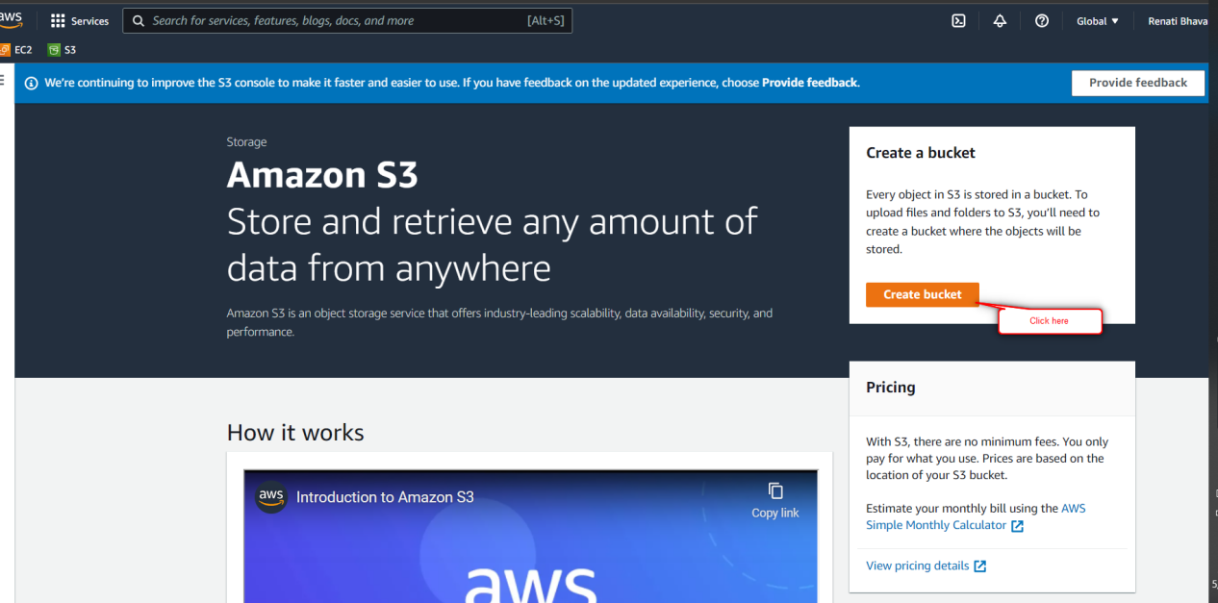

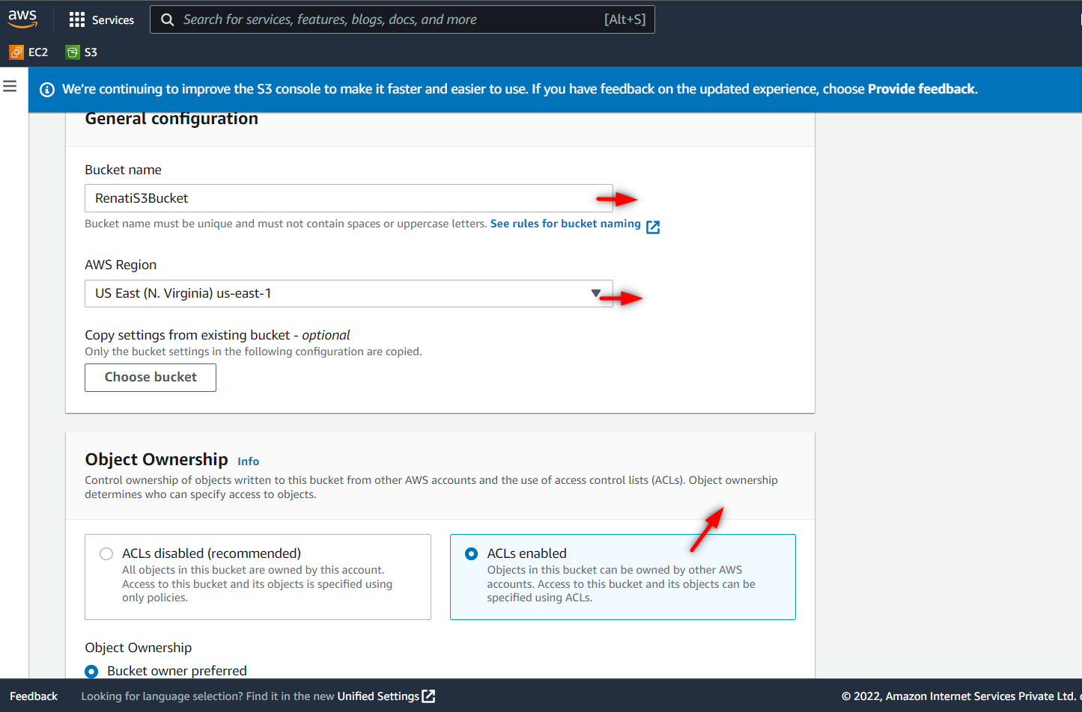

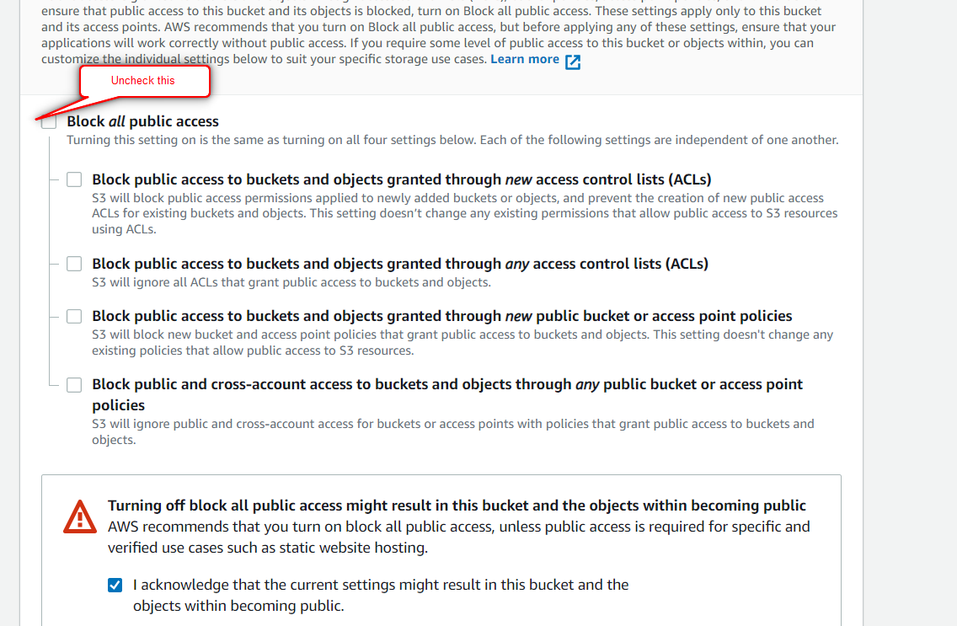

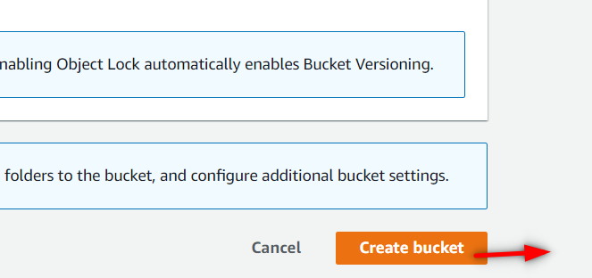

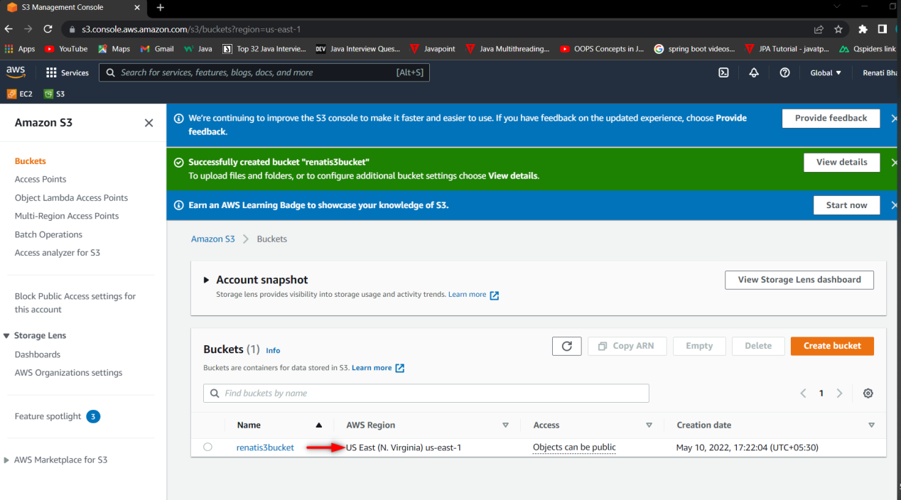

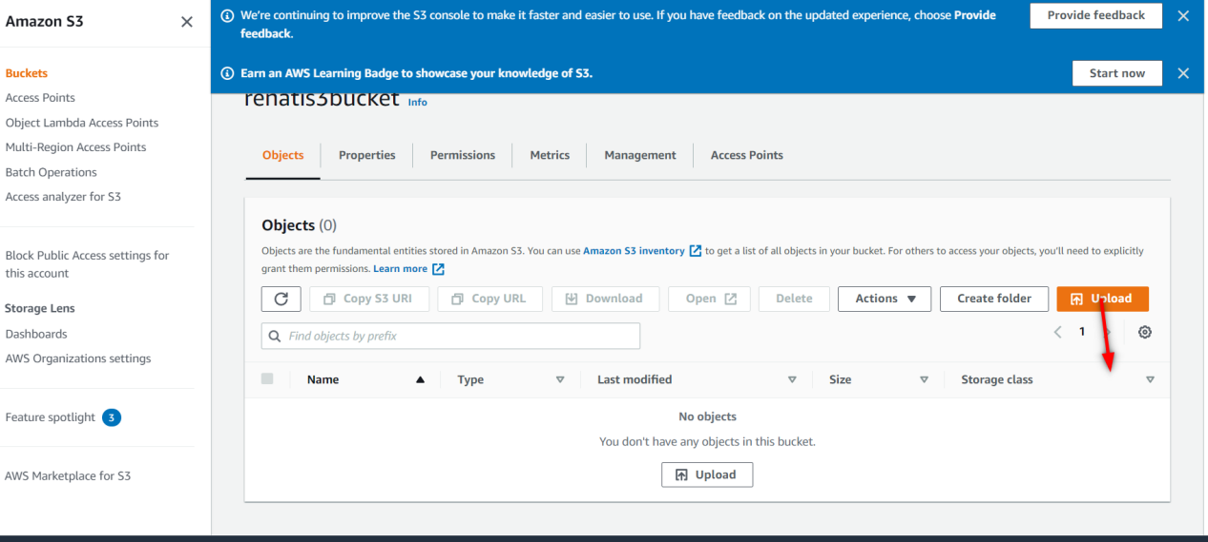

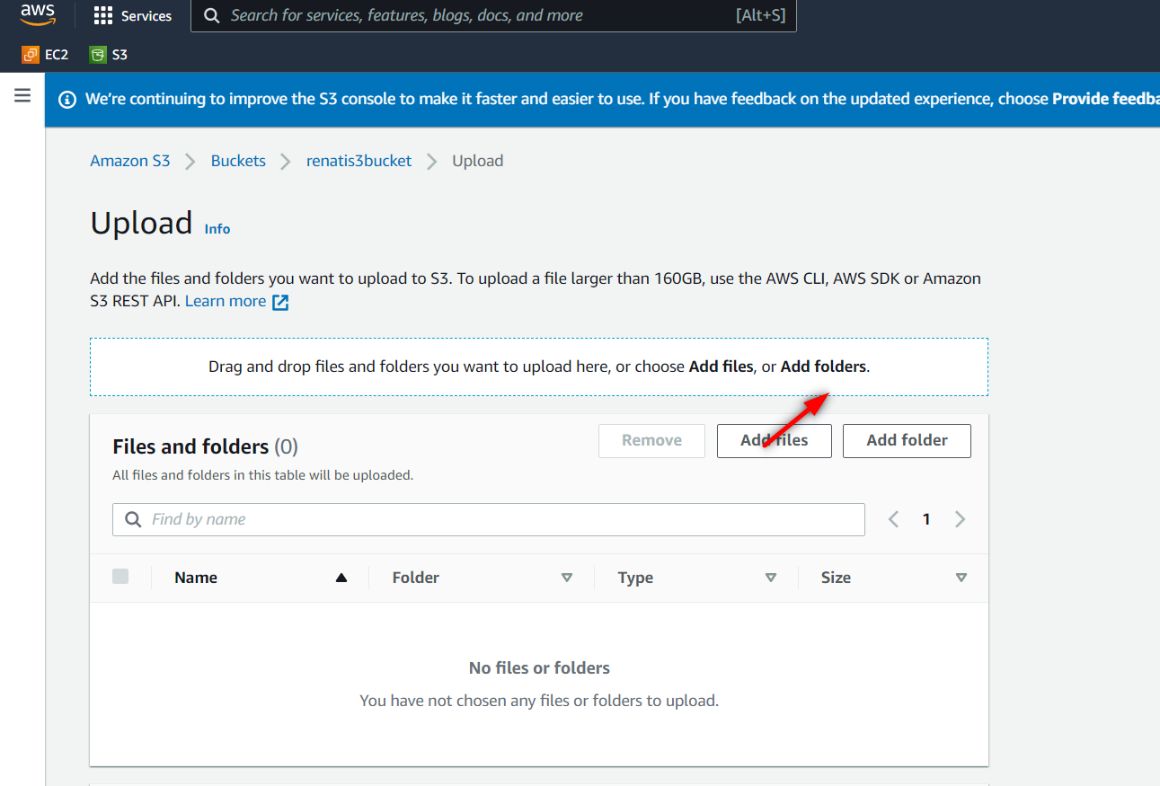

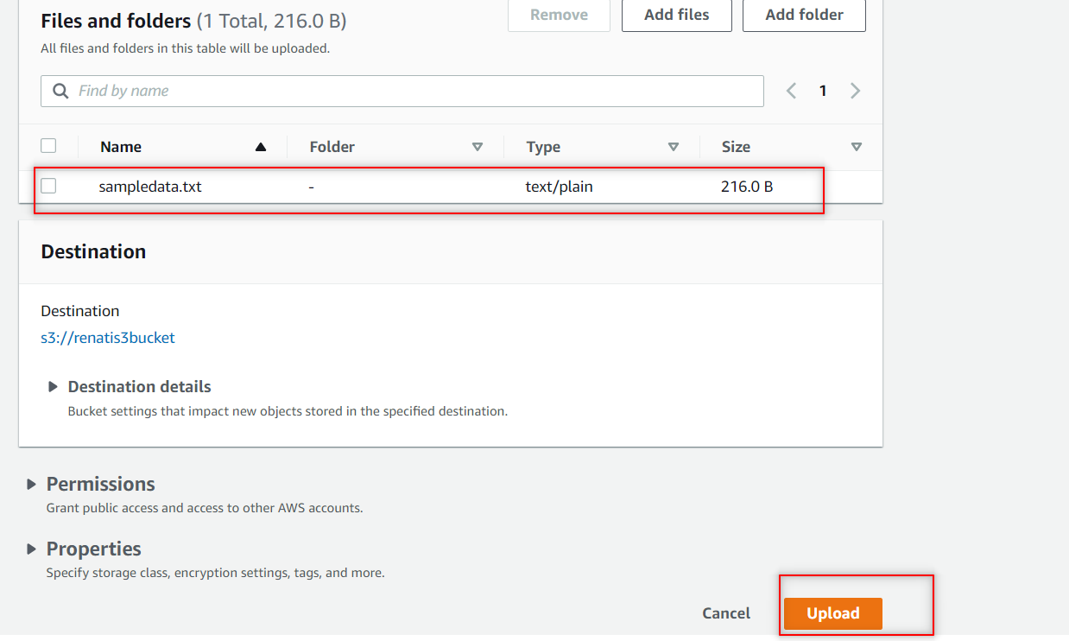

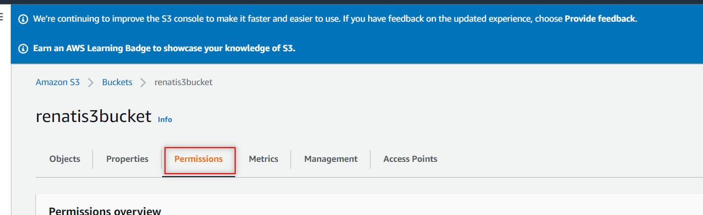

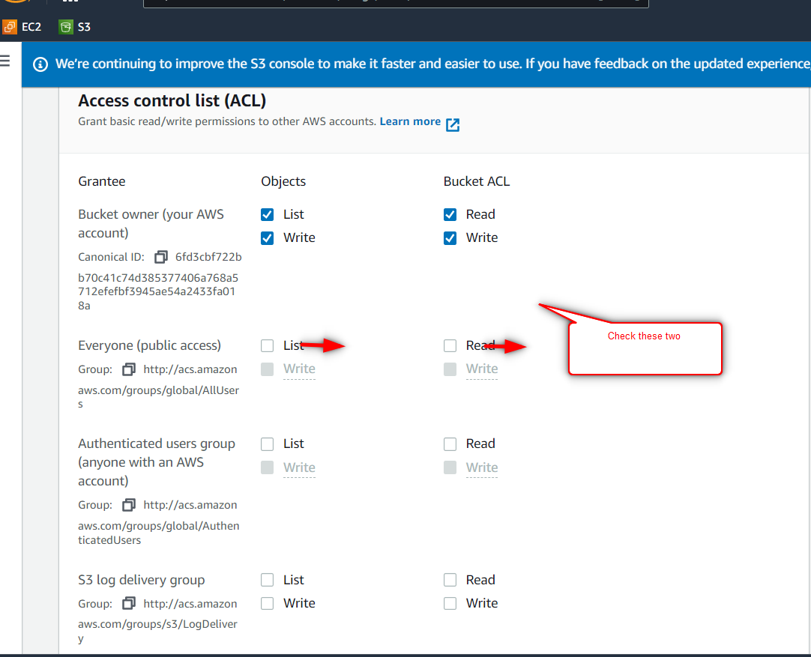

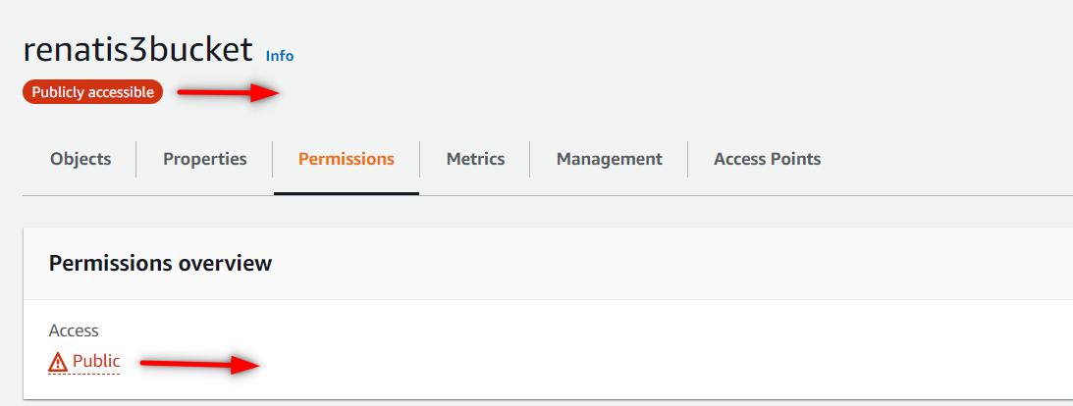

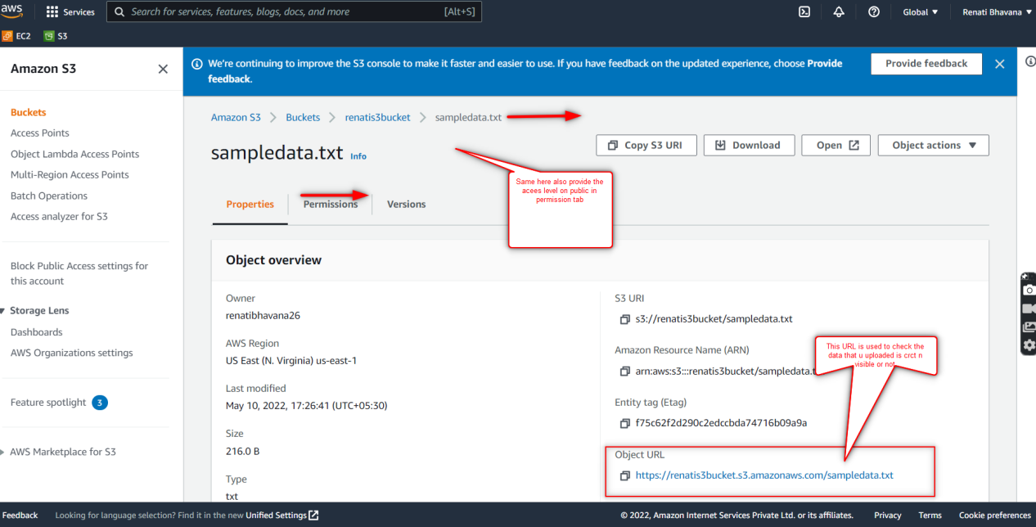

1. **Create a role if s3 read only is not available**

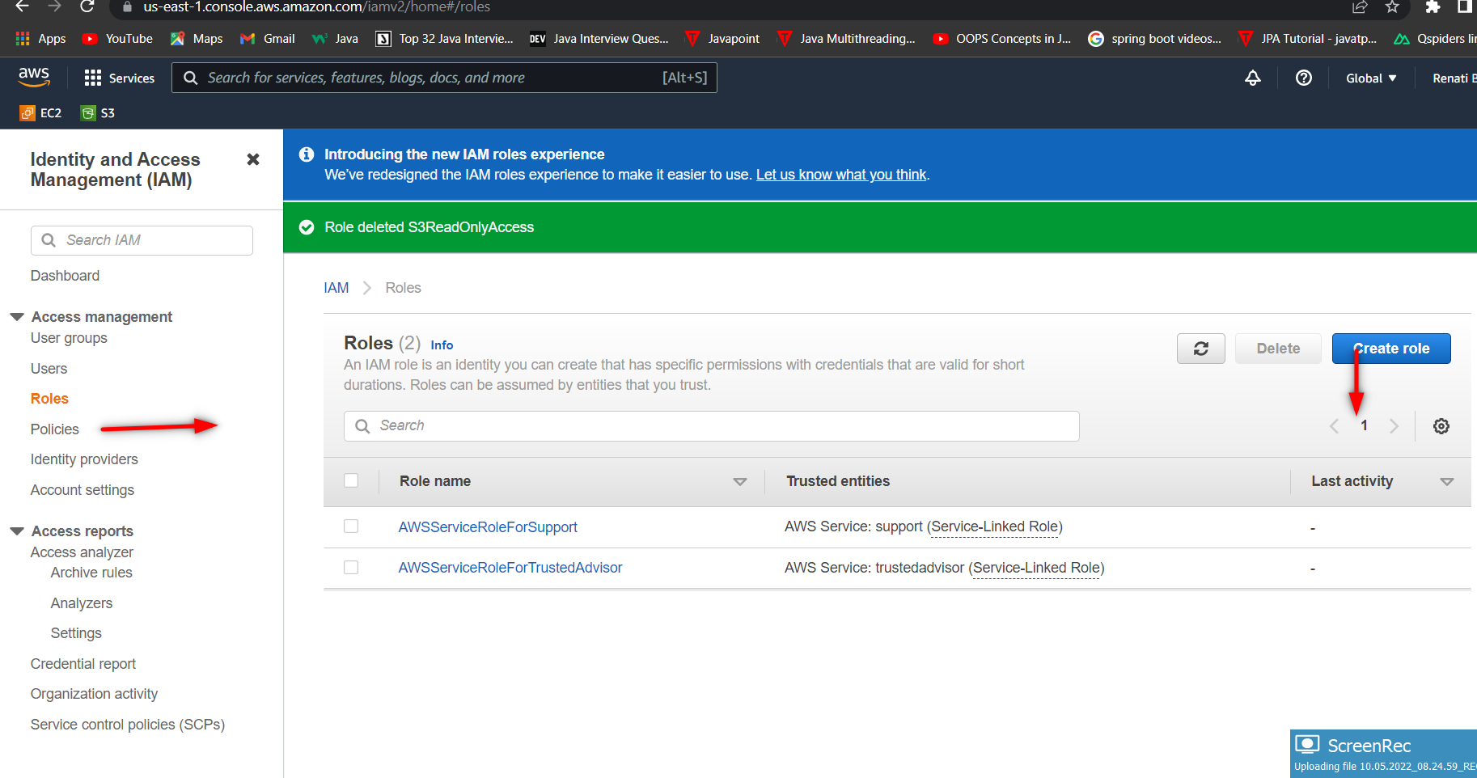

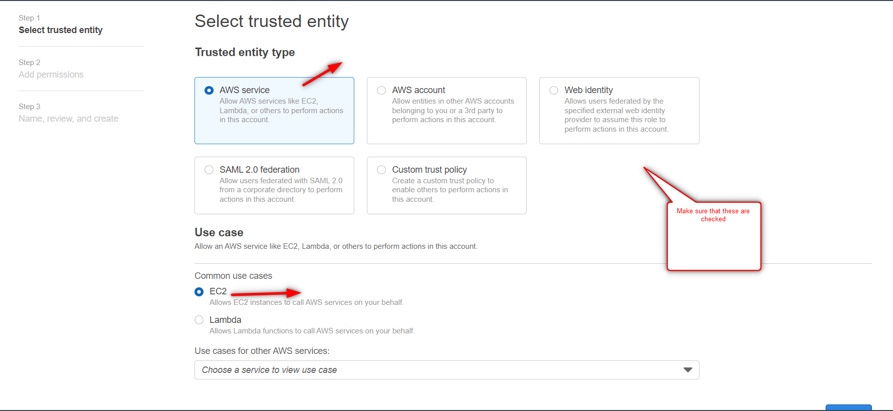

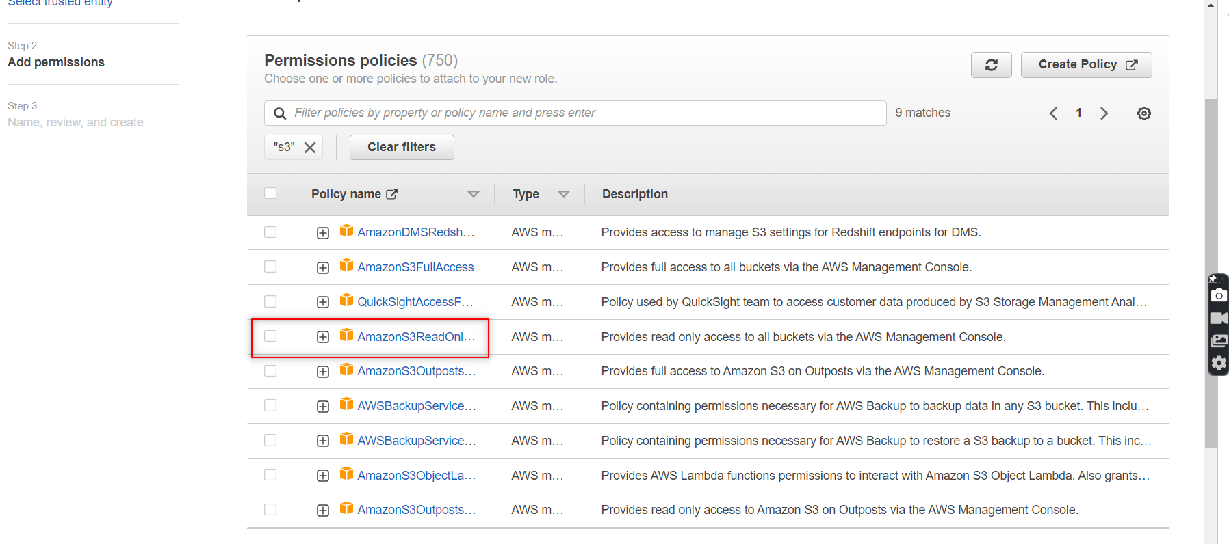

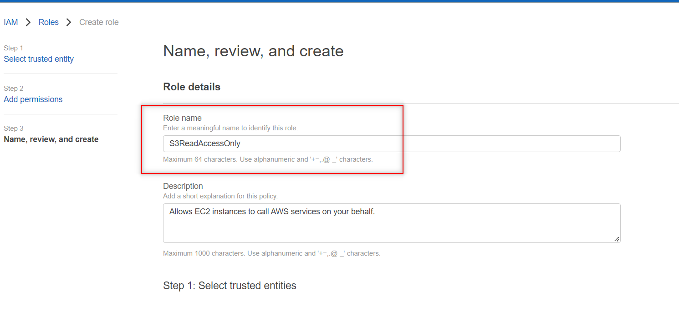

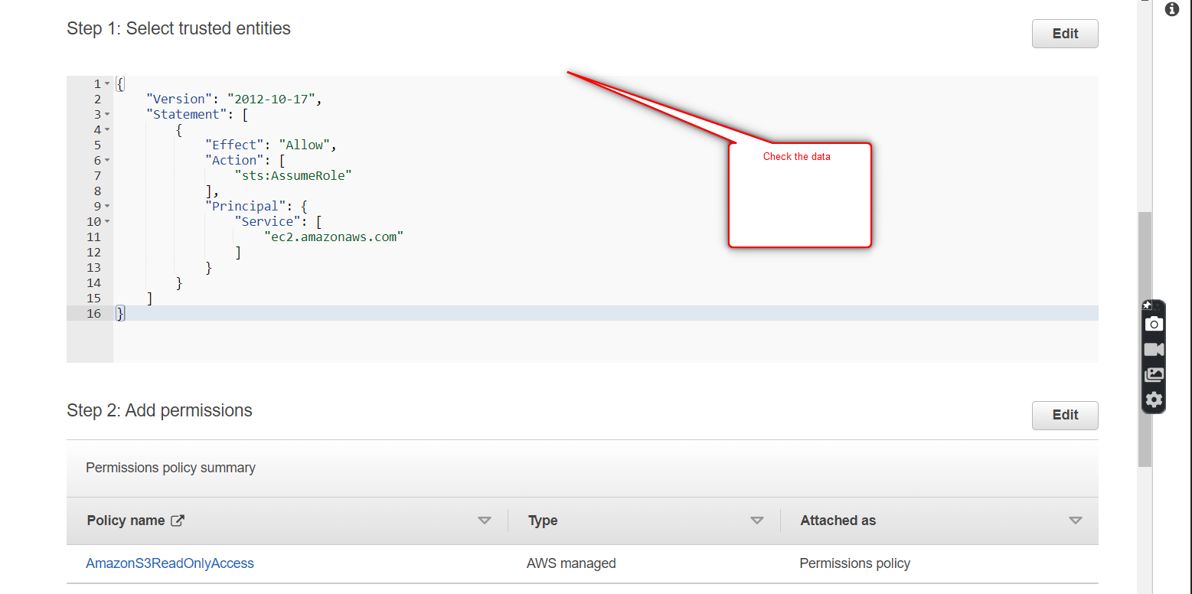

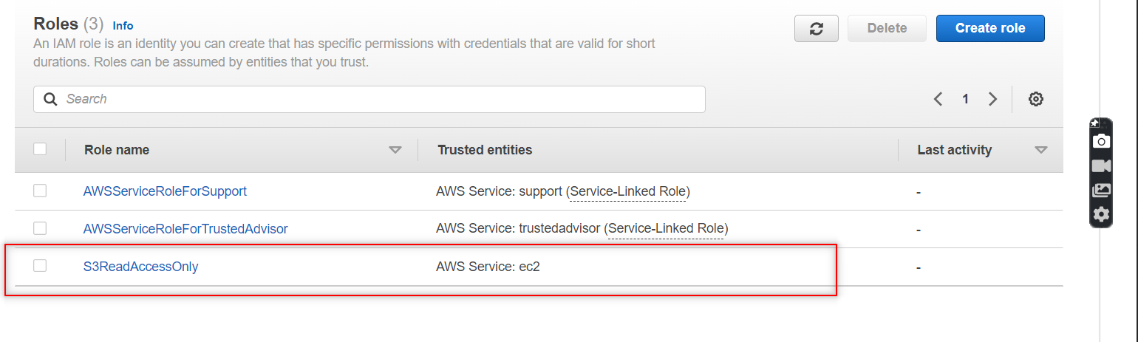

1. **Launch amazon linux 2 with user data.**

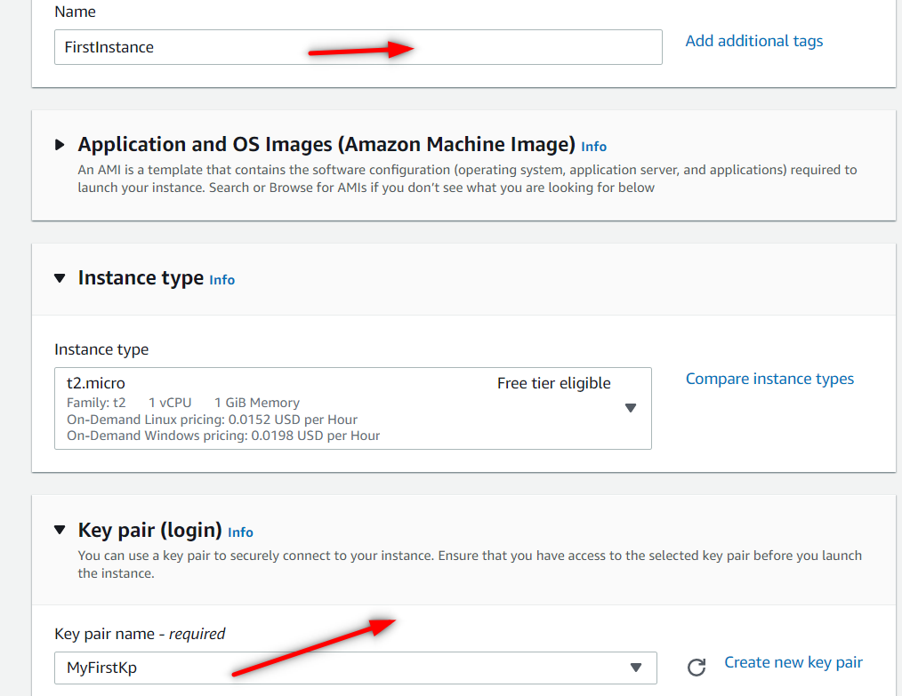

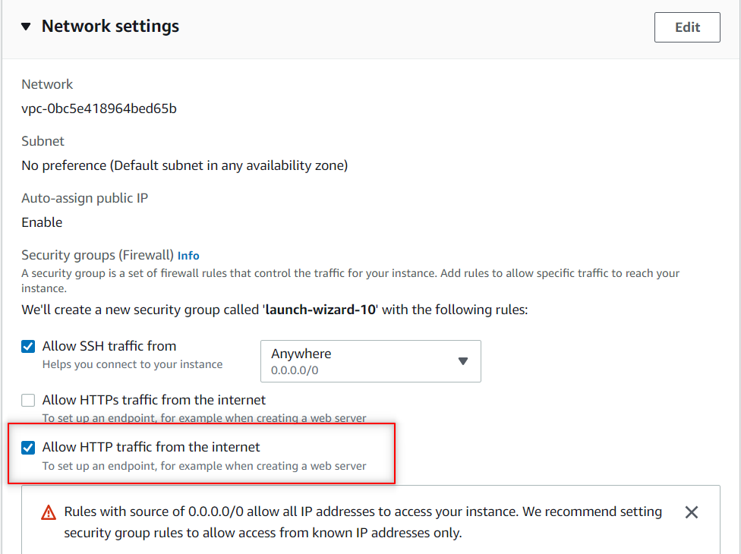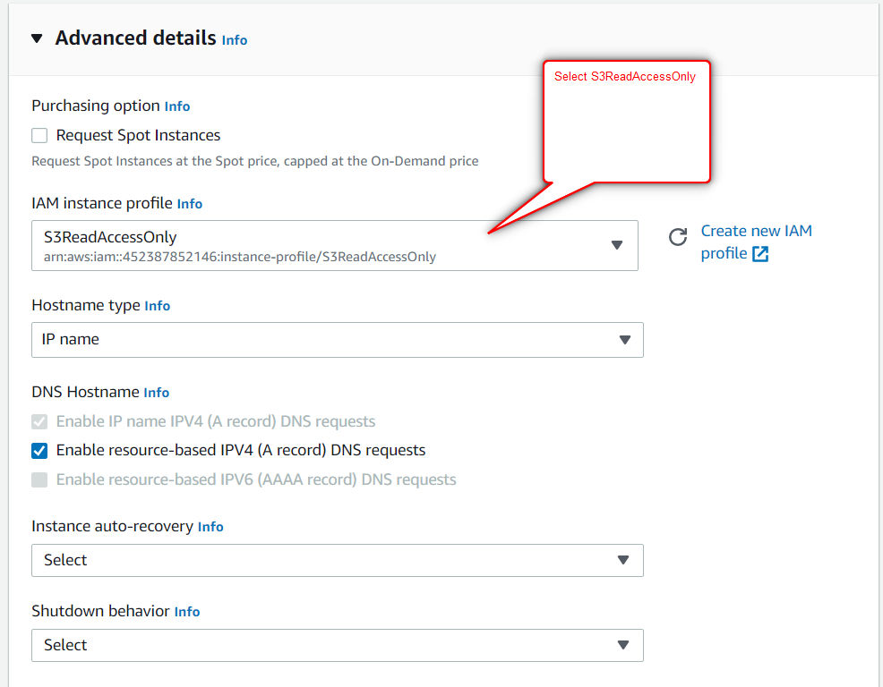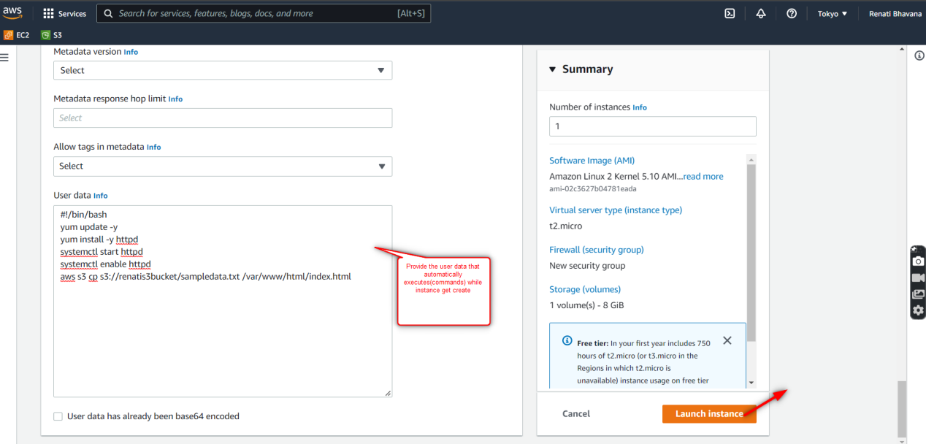

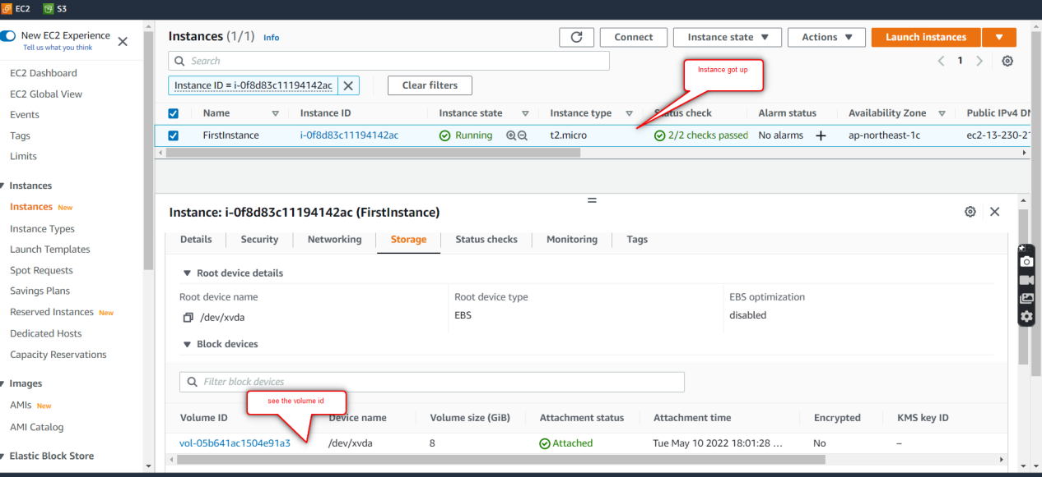

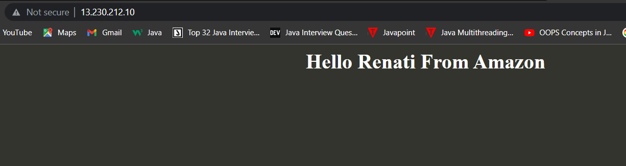

1. **Create a snapshot from the volume.**

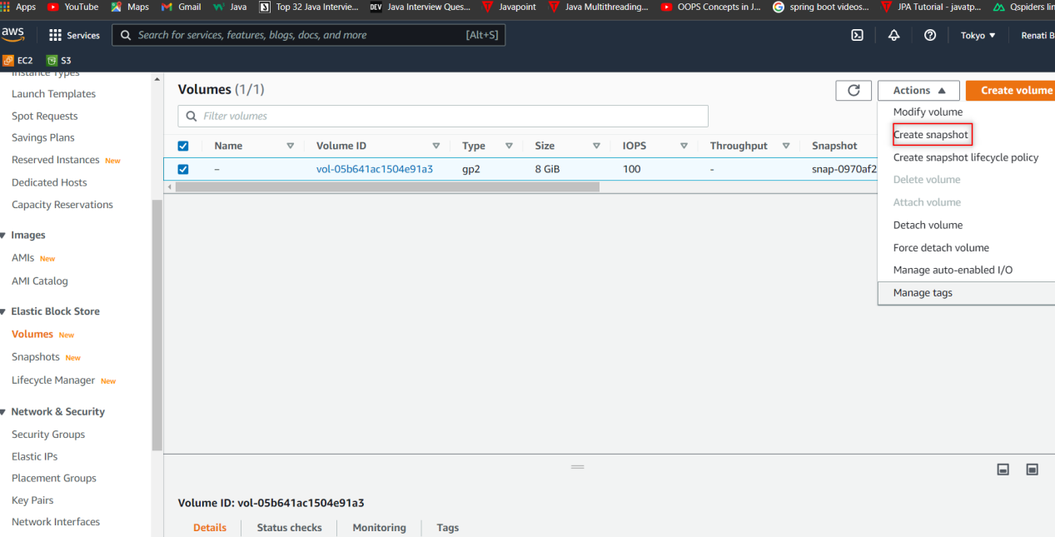

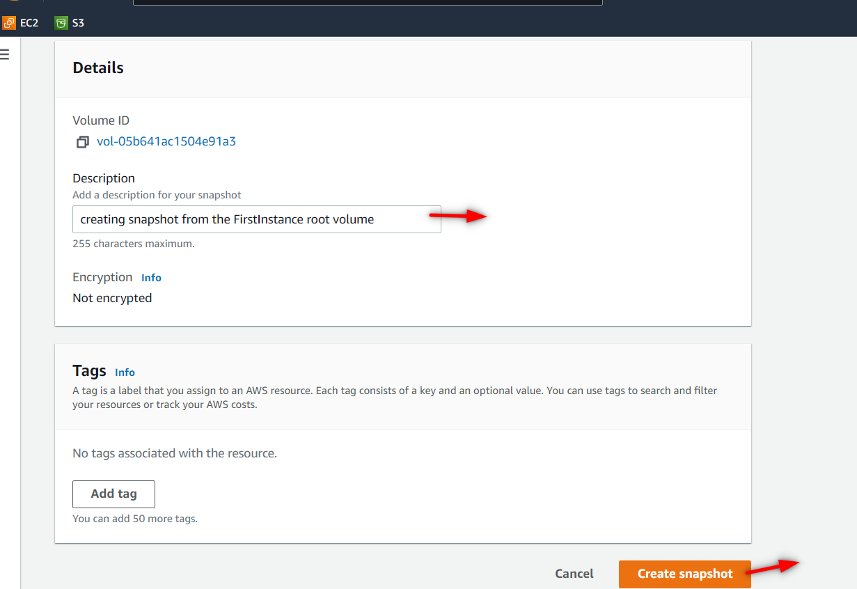

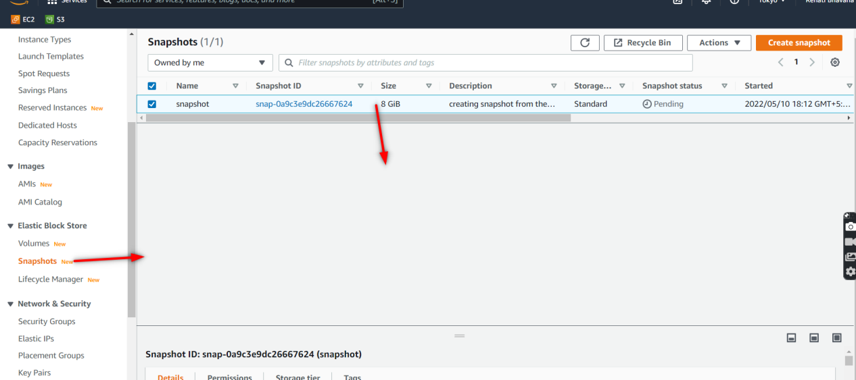

1. **Create AMI from the sanpshot created**

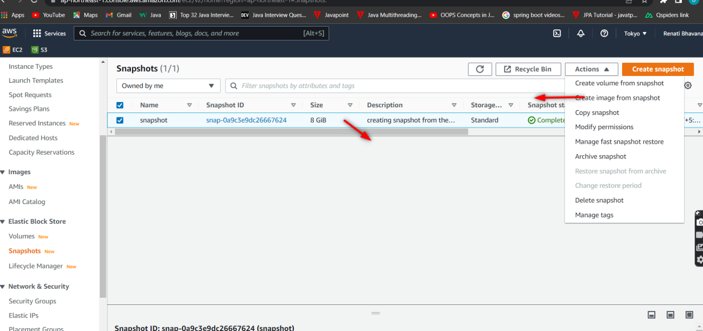

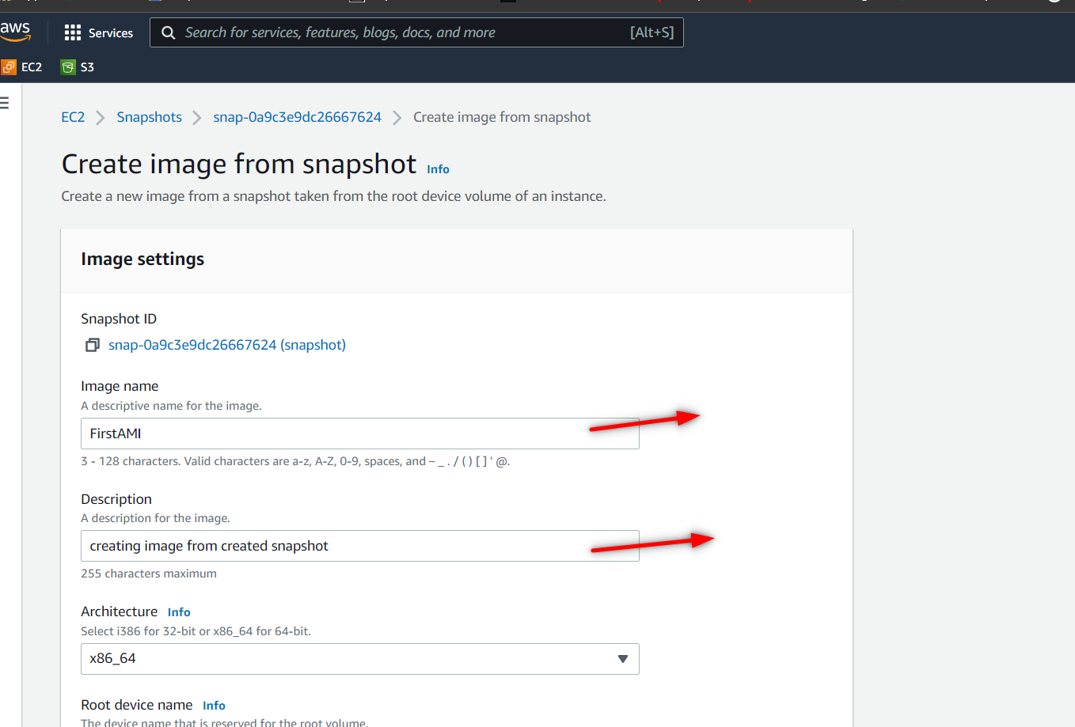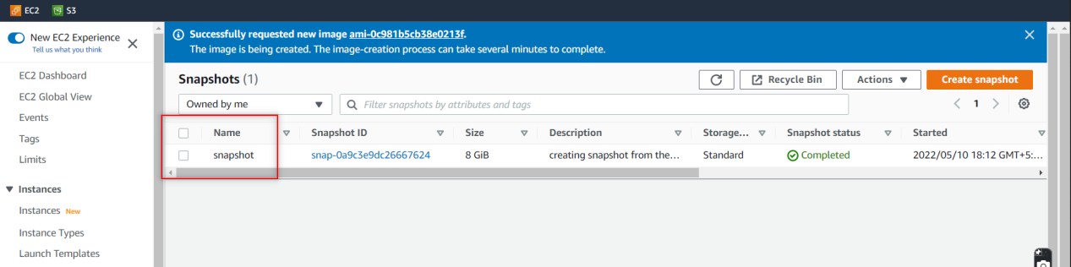

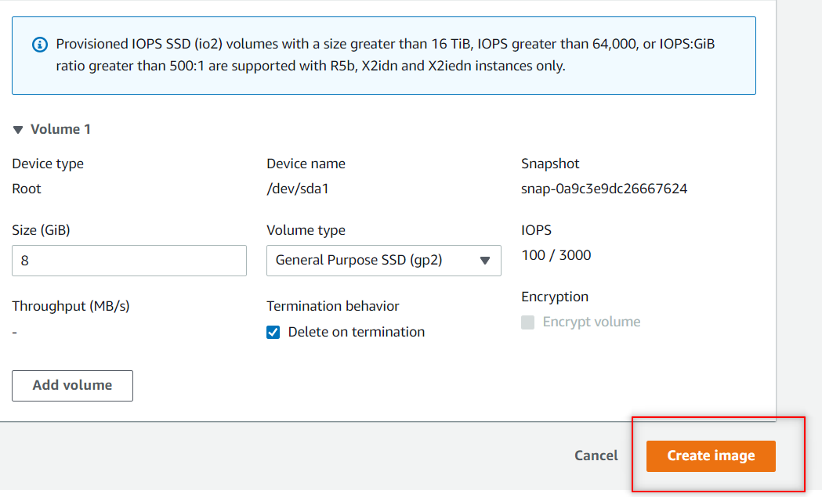

1. **Launch EC2 instance from the created AMI in different AZ**

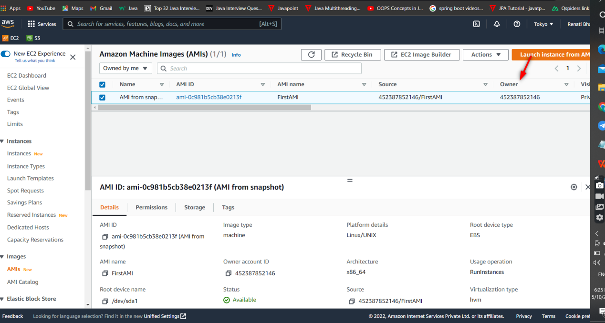

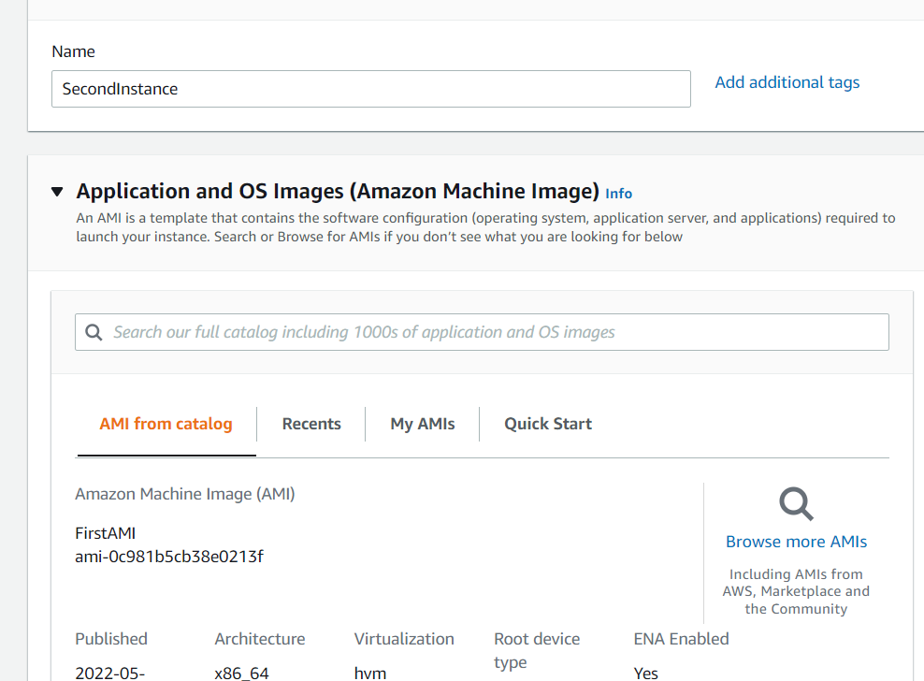

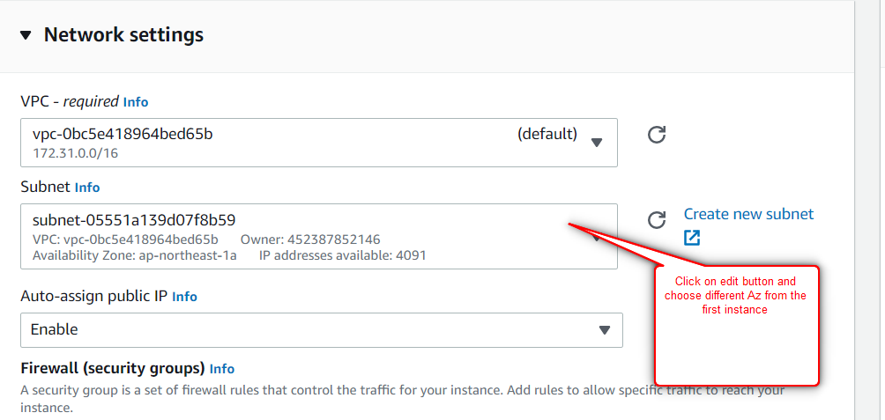

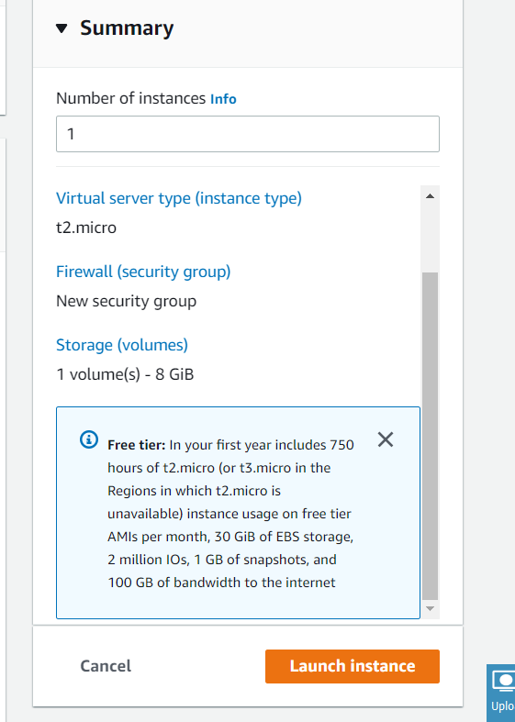

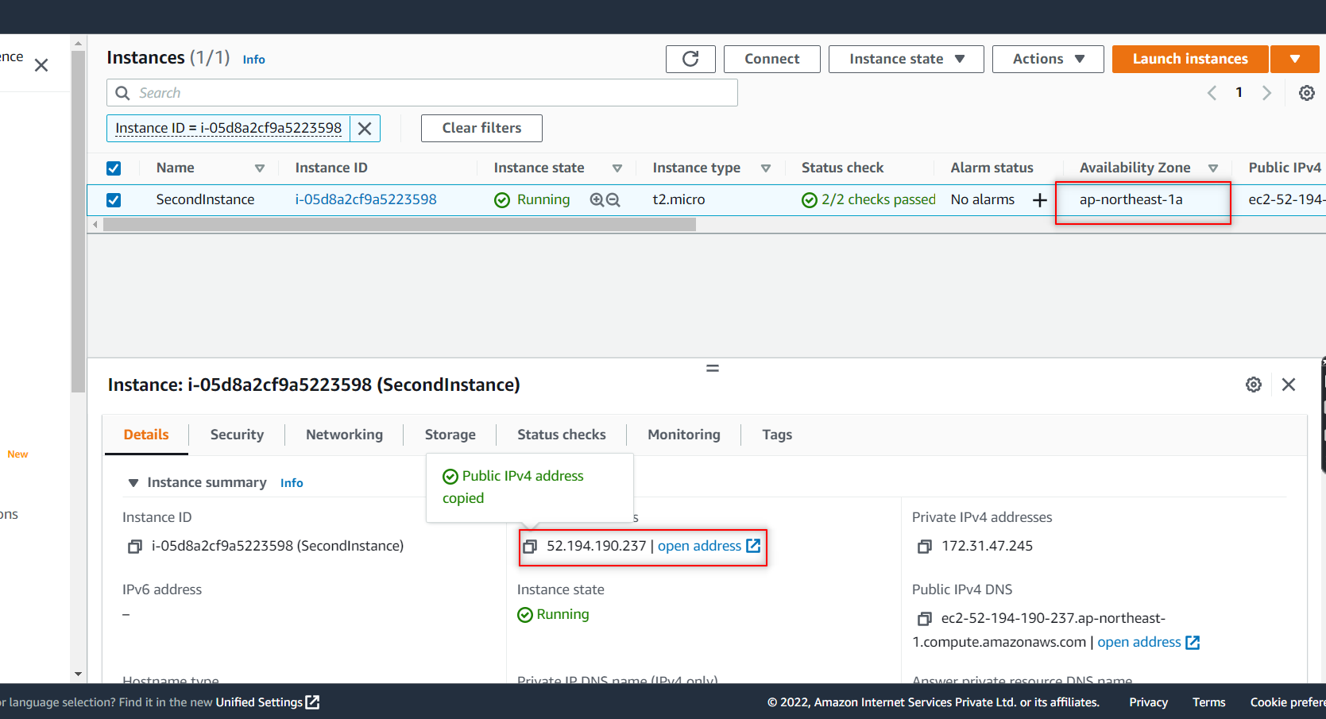

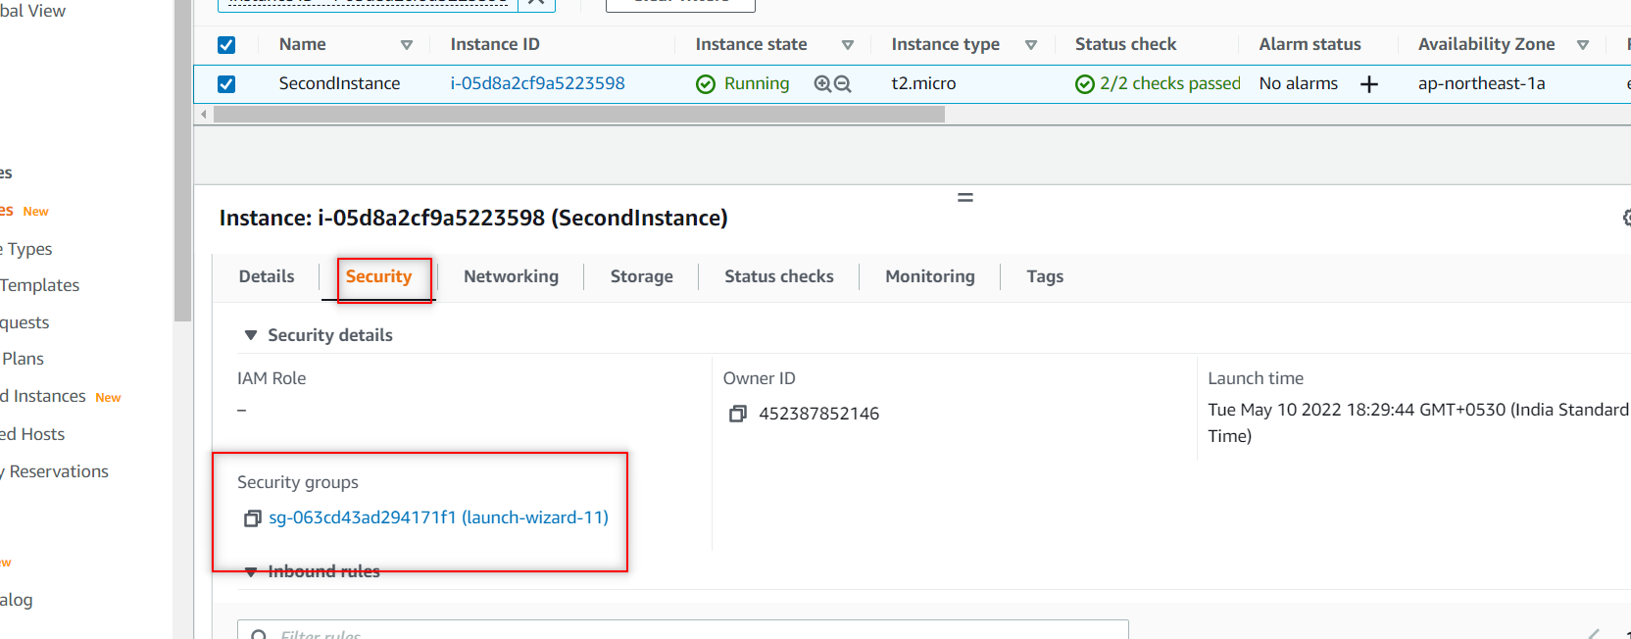

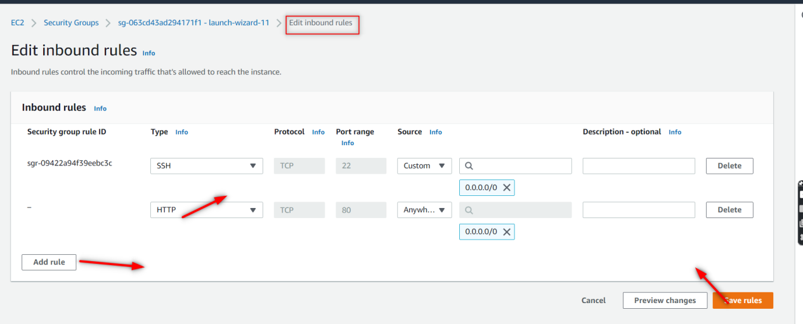



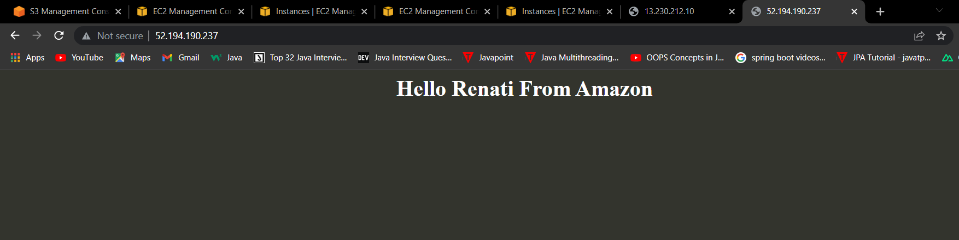

1. **What is Same region Replication(SRR)?**

Same-Region Replication (SRR) is **used to copy objects across Amazon S3 buckets in the same AWS Region**. SRR can help you do the following: Aggregate logs into a single bucket – If you store logs in multiple buckets or across multiple accounts, you can easily replicate logs into a single, in-Region bucket.

1. **What is Cross Region Replication(CRR)?**

* Cross Region Replication is a feature that replicates the data from one bucket to another bucket which could be in a different region.
* It provides asynchronous copying of objects across buckets. Suppose X is a source bucket and Y is a destination bucket. If X wants to copy its objects to Y bucket, then the objects are not copied immediately.

****Some points to be remembered for Cross Region Replication****

* ****Create two buckets:**** Create two buckets within AWS Management Console, where one bucket is a source bucket, and other is a destination bucket.
* ****Enable versioning:**** Cross Region Replication can be implemented only when the versioning of both the buckets is enabled.
* ****Amazon S3 encrypts the data in transit across AWS regions using SSL:**** It also provides security when data traverse across the different regions.
* ****Already uploaded objects will not be replicated:**** If any kind of data already exists in the bucket, then that data will not be replicated when you perform the cross region replication.

**9. How to delete a snapshot??**

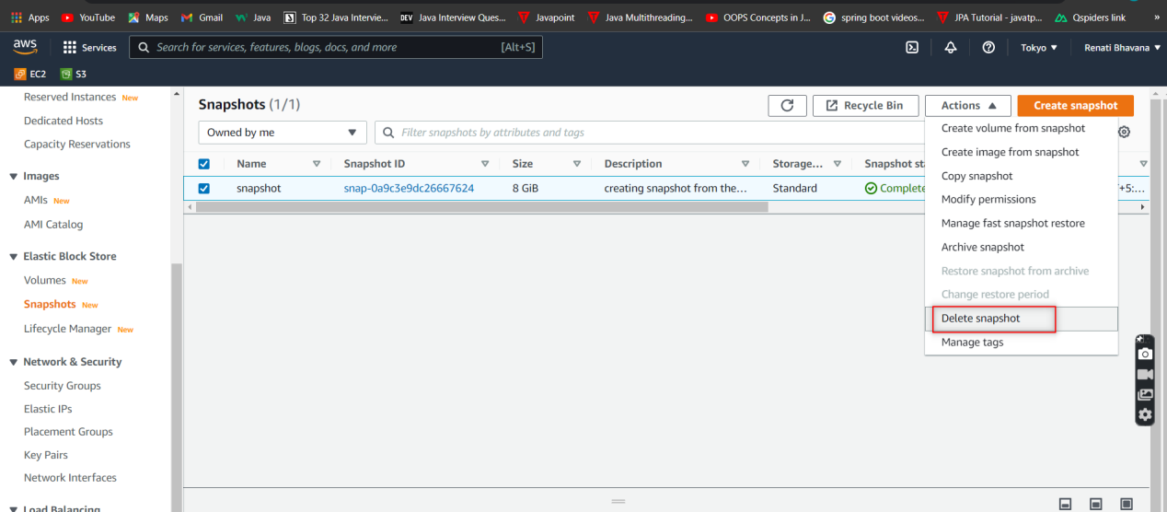

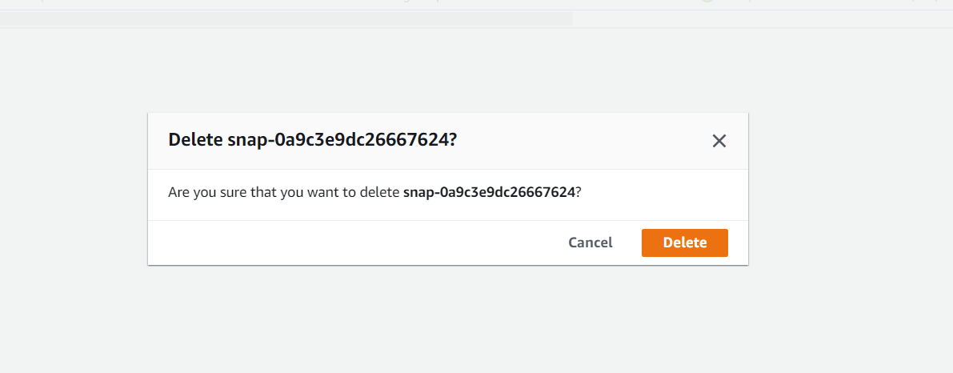

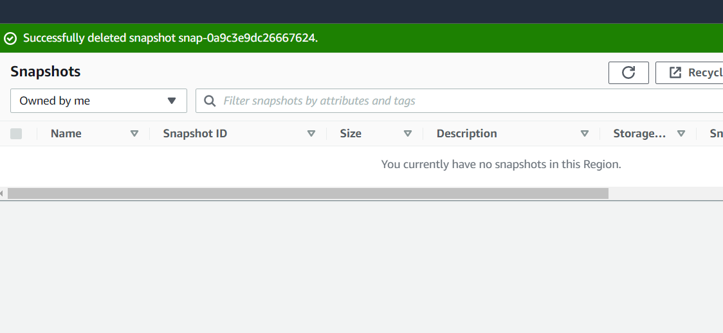

1. **HOw to deregister your AMI?**

